EMLACE - operations
Start up, shut down procedures
System warm up times
24 hours - AMS
1 hour - Humidifier
30 minutes - CCN - pad soaking
TSI Nephelometer
Aethalometer
SMPS
10 Minutes - Radiance nephelometers

Independent systems

AMS (Derek)
Aerodyne AMS Monitoring Operations Handout

Once collecting data, the AMS is designed to operate unattended (unlike, say, the CCN counter) and just requires monitoring by the scientist on-duty. As resetting and recalibration procedures are somewhat complex, apparent malfunctions should be reported ASAP (24/7) to me (DCM) and I will take care of what needs to be done. My contact information is as follows:

Home phone: 721-8055 Office phone: 766-4949 Cell phone: 760-9485

Checks to be performed at the start of (and occasionally throughout) your duty shift:

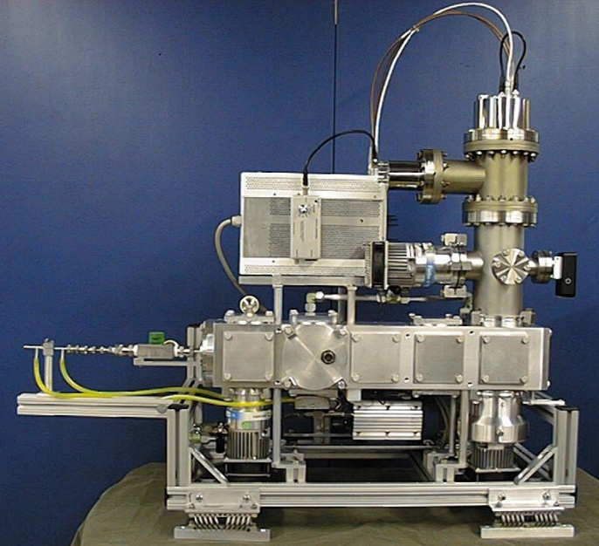
View Filament
Sample Inlet Valve
Pump #2
Chopper Window (on top)
1) Is the filament glowing? (Look in end plate). It should be illuminating the chamber. If it’s dark in there, CALL!

2) Touch pump #2. If it’s too hot to touch, CALL, and perform pump current check (item #4 below).

3) Look through the Chopper window and verify (visibly) that the chopper is moving every 10 or so seconds. (You can see the chopper mount moving and the 15 mm diameter 4-arm white plastic cross partially rotate back and forth).

4) Turbo Pump Current Check. On the Turbo Pump Controller (pictured on the next page), select pump #2 with the rotary knob labeled #1 in the picture. Check that the toggle switch (labeled #10) in the picture is set to current, and read the current value in the display. For sampling it should be about 3.3 – 3.7 amps. If it drops below 3.0 amps or, more importantly rises above 4.0 amps CALL immediately! Using the selector knob (labeled #1) select each pump in turn and read (and note) the current values. Typical values are shown below for the sampling mode.

Typical turbo pump current values (note: there is no pump #1):

Pump # 2 3 4 5 6
Current (amps) 3.55 1.26 0.28 0.22 0.32
If Pump#2 is < 3 or > 4 → problems

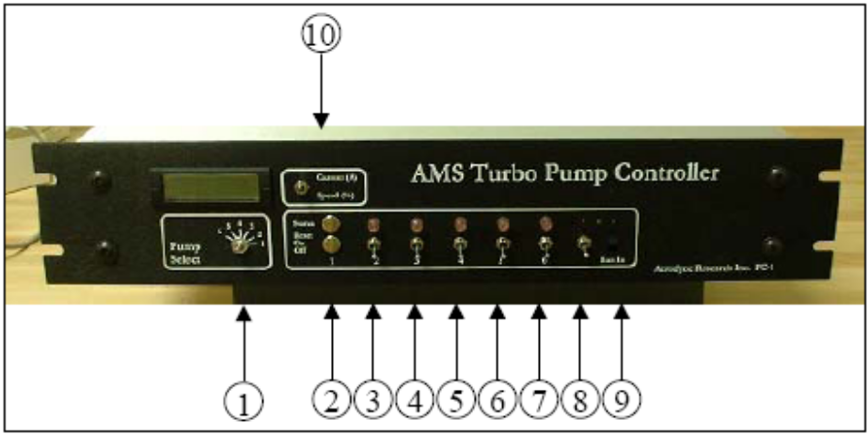

4) Check the heater temperature (T_{htr}) on the AMS Electronics box , as follows:

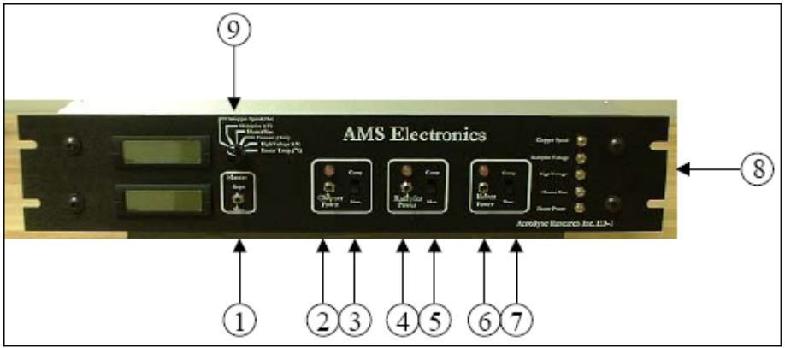

Set rotary selector switch #9 (above picture) to “Heater Temperature”, and read and note value in the display. It should be about 570° ±15°C.

5) Using the same rotary selector knob, choose “Chopper Speed”. Note and record value. (Should be ~110 - 113).

6) Using the same rotary selector knob, choose “Pressure”. Read and note value. (Should be ~ 1.15 – 1.16).

7) Now take a look at the display on the monitor. When sampling, the instrument automatically cycles between the Mass Spectrum (MS) and the Time-of-Flight (TOF) modes every ten or so seconds.
Pictures of the screens in each mode are given below. Note that the spectra may look quite different from the illustrations.

The Mass Spectrum (MS) mode:

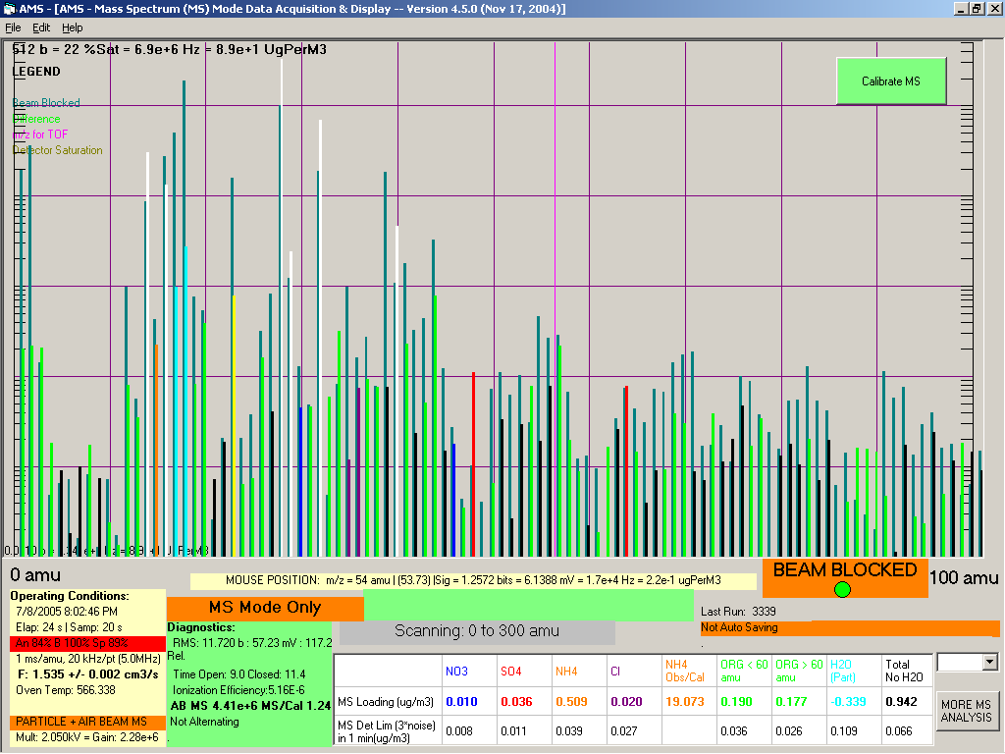

When the screen shows the MS mode, check that the display cycles between ‘BEAM BLOCKED’ and ‘BEAM OPEN’ (lower right).

Check and note the Flow Rate value given in the bottom left straw colored panel (‘F: 1.535’ in the example). If this value drops below 1.3, let me know. If it’s below 1.0, CALL immediately.

Read and note the Airbeam signal value, given as “AB MS” in the green panel of the diagnostics data display. Example shows 4.41e+6. It should be above 3.0e+6. If it’s 2.5e+6 – 3.0e+6 let me know. CALL if it’s below 2.0e+6 straight away.

Also read the MS/CAL value, immediately to the right of the Airbeam value. Example shows 1.24. This value will always be below 1.0 during the project. Let me know if it drops below 0.75 (not an emergency).

Check that the display below the ‘BEAM OPEN/BEAM CLOSED’ indicator says ‘Will save in xx m xx s at xx:xx in Run yyyy’, where the xx and yyyy values specify times and the run number. If the display says ‘Not Autosaving’, CALL immediately.

The Time-of-Flight (TOF) mode:

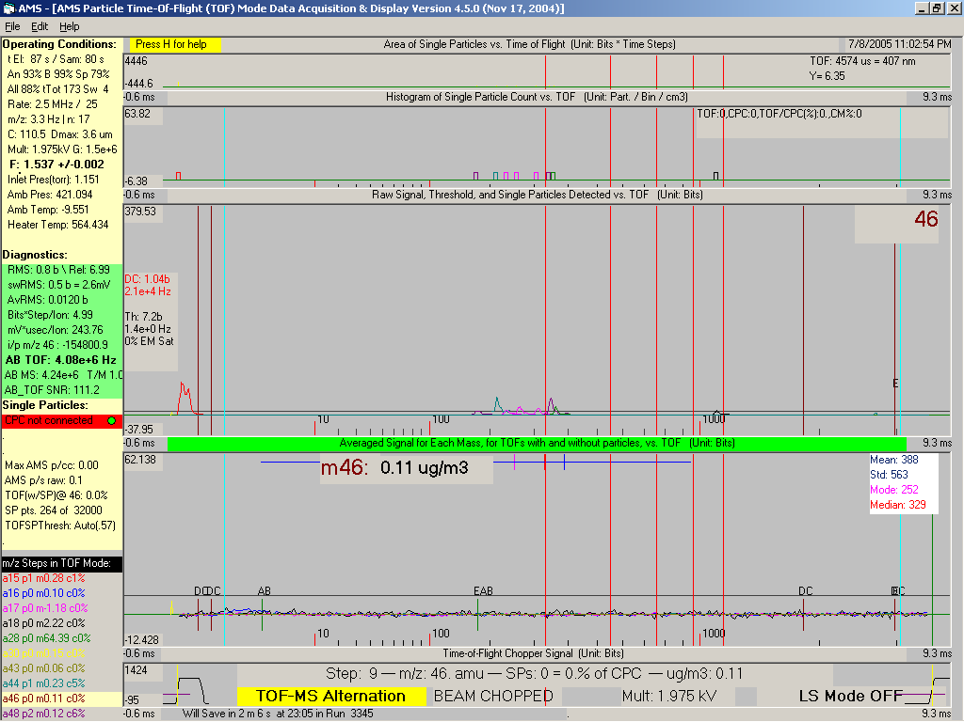

When the screen shows the TOF mode (as above), check and note the flow rate value in the straw colored panel (upper left). This is the F value (1.532 in the example).

Read and note the Airbeam signal value, given as “AB TOF” in the green panel of the diagnostics data display. Example shows 4.08e+6. It should be above 3.0e+6. If it’s 2.5e+6 – 3.0e+6 let me know. CALL if it’s below 2.0e+6 straight away.

EMERGENCY PROCEDURE e.g. IF THE POWER FAILS

For power failure, the alarm on the UPS will beep. Immediately

1) CALL me so that I can come over. (721-8055 then 760-9485)

- ROTATE THE SAMPLING INLET VALVE (labeled in the photo) CLOSED. IT TURNS 90°.

- ON THE COMPUTER KEYBOARD HIT ‘q’ TO STOP SAMPLING.

DO NOTHING ELSE FOR 20 MINS! If I have not arrived 20 minutes into the emergency, then if the power has not come back on,

- CHECK THAT THE SAMPLE INLET VALVE IS CLOSED, AND TURN OFF THE TURBO PUMPS (switches 3 through 7) on the AMS Turbo Pump Controller.

- TURN OFF THE HEATER, MULTIPLIER, AND CHOPPER POWER SWITCHES with the three switches on the AMS Electronics box.

- TURN OFF THE POWER ON THE BALZERS (Pfeiffer) QMS ELECTRONICS CONTROL BOX (switch is on the front panel, lower left). No illustration of this controller box. It is the whitish-grey box mounted immediately above the white Tripp-Lite UPS.

- TURN OFF POWER TO THE ELECTRONICS (SW3) AND THE TURBO PUMPS (SW2) on the AMS Power Supply, but do not turn off SW1, the power to the Diaphragm Pump.

- EXIT THE PROGRAM (hit EXIT PROGRAM button). Shut down the computer as per usual.

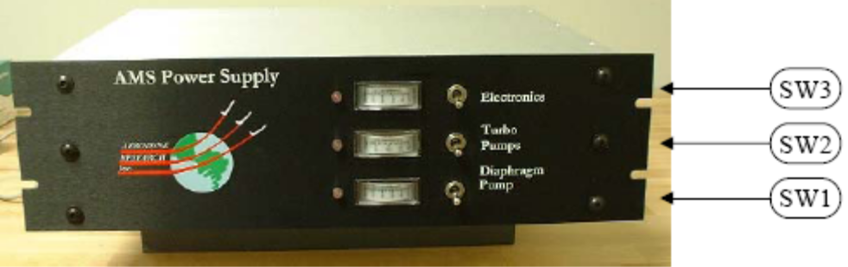

If the power comes back on before the 20 minutes wait time are up, DO NOTHING other than steps 1 through 3 above.

Humidification system (CPU - Christopher) (Perry)
System Description: The humidification system consists of a humidification control head (Naphion), a humid purge air supply, a dry purge air supply and a LabView based controller. The aerosol sample is pulled through the control head, and the RH of the sample is increased or decreased according to a pre-determined ramp function.
Control of the RH of the sample is accomplished by switching in humid, or dry purge air and controlling the flow rate (and pressure) of the purge source.

Startup Procedure:

- Check that there is sufficient water in the water bath. The bath should be cleaned and re-filled with 4 liters of water before the start of an experimental intensive period.
- Power up the system by energizing the power strip on the bench. The power strip on the floor should always be on!
- It will take approximately 40 minutes for the bath heater to stabilize the temperature of the humidity bath.
- Boot the controller computer (Christopher) using the login: administrator, passwd: n2uwdata
- Double click the hpid2 shortcut icon to bring up the controller.
- Insure that a fresh Dri-rite dryer is attached to the system. If in doubt, replace the silica in the dryer. NOTE: Silica is not healthy to breath. Change silica under the fume hood.
  - Empty the silica into a crucible and ‘cook’ it for at least 8 hours to dry it. Pour the dry silica in a labeled jar and close the lid tightly.
- Wait until the vacuum system is running, and verify connections per the connection diagram.
- After the system has had time to pre-heat, and the silica dryer has been checked, press the ‘RUN’ arrow on the LabView control window.
  - The system will initialize by driving the RH to 25%, then starting the RAMP function.

NOTE: Do not change any of the settings on the LabView control panel!

Operational Checks:
- Monitor the ramp function of the process variable on the LabView control panel display. If it appears abnormal (i.e. slow or non-responsive):
  - If the ‘ramp up’ function is not working properly, check the humidity bath connections and make sure that the system has not ingested liquid water.
  - If the ‘ramp down’ function is not working correctly, check the Dri-rite dryer (change desiccant) and make sure that the system has not ingested liquid water.
  - If the system has ingested liquid water, it will need to be purged with dry air for at least one hour.

Shutdown:
- Press ‘STOP’ button on the LabView panel. USE THE BUTTON, not the ‘STOP’ sign.
- Close the LabView application.
- Shutdown the computer.
- Turn off the top power strip.

Filter packs (Mark) - Filter change-outs

Frequency: Daily, during 1800 UTC checks and changes

Description: Pairs of filter cassettes are located in flow circuits “2” and “3a”. Each pair of cassettes, 4 in all, will be removed, physically protected, then placed in cold storage. The flow rate through the circuit will be checked upon removal of the exposed cassettes, and again upon installation of new cassettes. Cassettes will be handled with gloved hands, and stored in cold storage.

Equipment Needed: Dust free gloves, ziploc bags for exposed cassettes, standard screwdriver for hose clamps, electronic mass flow meter with adapter, clean protected replacement cassettes, Teflon tape. Project log book – record all activities and observations.

Safety: Wear safety glasses. Be especially careful if/when turning on the vacuum pump and opening flow lines to keep loose clothing and hair away from all openings and machinery.

Procedure: During the daily 1800 UTC (noon local) turnaround, filter cassettes will be replaced.

Note; The filter cassette holders are bulky, cumbersome, and mate plastic to metal. Handle and set down with caution. Wear dust free gloves when handling filter cassettes.

- Have on hand the appropriate filter cassette storage ziplocs, and the appropriate replacement filter cassettes, stored cool in a cooler.

- After turnaround procedures have been initiated, loosen the hose clamp and disconnect line 2 upstream of filters in 2a and 2b. Connect the flow meter with adapter and record the final filter flow rate on the appropriate ziploc and in the log book.

- One at a time, disconnect the quick-connects upstream of each cassette. With gloved hands, carefully remove each of the pair of 2a/2b filter cassettes. Cap and store the removed cassettes in their marked ziplocs. Record removal time/date on the ziploc and in the log book.

- With gloved hands, carefully remove each of the new pair of 2a/2b filter cassettes from their ziplocs and install them in the cassette holder. Use Teflon tape on the threads. Record the replacement time/date on the ziploc and in the log book. Carefully reattach the quick connects, and flow meter and record the installed filter flow rate on the appropriate ziploc and in the log book.

- Reconnect line 2 to the inlet manifold by carefully rotating it into its receiver. Use a light coat of vacuum grease if warranted. Evenly tighten the retaining hose clamp.

- Relocate to flow circuit 3. Disconnect the line to the Radiance Nephelometer.

- In like fashion as for flow circuit 2 above, measure the final flow rate, remove and store exposed filters, re-install new filters, re-connect lines and measure new initial flow rate for filter cassettes in line 3a and 3b.

- Reconnect the Radiance Nephelometer line. Reconnect line 3 to the inlet manifold and be sure to evenly tighten the hose clamp

- Double check that filters are in their appropriate ziploc, and that the ziplocs are labeled with on and off dates/times, and initial and final flow rates. Record all information in log book

Vacuum System (Don)
Power on
- Check to see the oil reservoir on the pump is not less than about 30% full.
- Insert the large plug attached into the wall - It is a unique twistlok, so fits just the one plug, on the wall behind the environmental chamber. It will fit just one way, and when fully engaged, will turn slightly to lock in place. This is 220VAC, low amperage, so there should not be any fire works, but if there is pull the plug out and get one of the staff to check it immediately.

To verify operation:
- Read pump-press on the Keck data system: it should be about 256 mb +-about 5 mb.
- If it is above 350 mb, the system is not funtional, probably because of a very large leak somewhere, which is likely to audibly hiss.
- If it is above 256 mb, something is likely to be going wrong - either with the pump, or because of smaller leaks in the system.

Power down - Unplug from the wall

Flow rate checks (Mark)
Frequency: Pre-, mid- and post-project.

Description: The flow rates leading to 3 of the 4 major sample flow circuits will be checked, recorded, and corrected if out of specification. Circuit 1 serves the PCASP and APS. Circuit 3b serves the Radiance Nephelometers. Circuit 4 serves the TSI Nephelometer and subsequent suite of instruments.

Equipment Needed: Gilibrator™ soap bubble flow meter, tubing and tubing adapters. Project log book – record all activities and observations.

Safety: Wear safety glasses. Be especially careful if/when turning on the vacuum pump and opening flow lines to keep loose clothing and hair away from all openings and machinery.

Procedure: The line of each circuit will be opened, the flow meter inserted, the flow checked and recorded, any corrections made, and the system returned to service.

Note; each circuit has a dis-connection point identified by a blue tape label.

- Have on hand the appropriate tubing and connectors, and have the Gilibrator™ readied for operation.
- With the vacuum/flow system operating at normal conditions, carefully disconnect (only one) circuit.
- Connect the flowing (vacuum) end of the flow circuit to the upper connector on the Gilibrator™.
- Measure the flow until stable, then record flow rate. Note any anomalies or unsteadiness.
- Remove the Gilibrator™ and connectors.
- Reconnect the flow circuit tubing, being sure to make an effective connection.
- Proceed until all three circuits are tested.
- Correct and problems and retest if necessary.

Keck CPU - Short version
- Plug PCASP in
- Click on Keck_Main.vi
- Create data file button should be green (don't touch unless black)
- Click on white go arrow
- Double click emlace folder, double click header file (largest number)
- Two black panel windows appear
- Click start recording - check that data are recording in bytes window
- Modify displays using buttons…

KECK DATA SYSTEM OPERATION - Long Version
Contact: Matt Burkhart, monoski@uwyo.edu, 766-4150 (office), 399-4960 (cell)

COMPUTER STARTUP
Startup the KECK computer by pressing the ‘1’ button on the UPS below the right of the desk.
Log into the system with the following: Username: keck, Password: aerodas
Wait for the system to stop “starting up” … the pointer will no longer change to an hourglass.

DATA SYSTEM SOFTWARE STARTUP
Double click the shortcut icon labeled “Keck_Main.vi” … This will bring up the main window that controls the operation of the Keck Data System.

Before starting the system, ensure that the PCASP is plugged in (turned on). This will minimize the possibility of a serial port error/spike.

In the Keck_Main.vi window. Make sure the “Create Data File” button is green so a data file will be created for the session. Press the white “run arrow” ⇨ in the top left of the window to start up all of the associated data system files and start taking data.

When prompted, select the most current EMLACE header. This is in the directory:
C:\Keck\Headers\EMLACE and will be the named EMLACE_zz.kfg, where zz is the version. Choose the largest number, as this is the most current header.

At this point, many windows will “pop” and change places as the system starts up. The window labeled “Keck_Realtime_Display_Panel.vi” should end up on top after a minute or so. This is the main display window and should have two black strip charts in the center of it. Do not try operating the buttons in any window before the system has completely started

Verify that the time and date box are correct and that time is incrementing and data is displayed.

RECORDING A DATA FILE
To start recording a data file press the “Start Data File” button on the top right of the Keck Realtime Display. The button should turn green and after a short delay the “Data on Disk” light should be bright green and the “Bytes to disk” field should start incrementing. Data file names are the current date plus a letter signifying the order. i.e. 20050713c_raw.nc This means that this was the third file opened on July 13, 2005. Files are native netCDF format.

STOPPING DATA FILE RECORDING
To stop the recording of a data file. Press the “Start Data File” button so that it turns a dull green. Ignore the fact that the “bytes to disk” field keeps incrementing.

RESTARTING A DATAFILE
To restart a data file (with a new name), first stop the current file. Press the “Restart Data File” button. It should light green for an instant. A new data file has been created on disk. You may then start recording a data file as you normally would.

CHANGING DISPLAYS AND VARIABLES
Press the “Modify Displays” button in the top left of the display panel. This will bring up a window with many rows of variable names.

Use the matched arrows  to select the variable to display in that position. You may also use the “finger tool”  to select from a list by clicking on the variable name you wish to change. You may change the “Digital Display” and “Chart” variables.

When finished, click the “Update Display” button to close this window and return to the display.

Note that when you change variables, the display panels refreshes and the charts restart, erasing any previous traces.

It is a good idea to run the “Modify Display” function after any header change to insure that the variables are mapped correctly.

CHANGING CHART LIMITS
You may change the bounds for the Y-axis on the charts for each variable if desired. To do so, move the mouse over the top OR bottom value on the Y-axis corresponding to the variable you wish to change the limits for.

Highlight this value. You may have to use the TAB key to select the “I-beam” text pointer.

Enter the new value. Press the “Checkmark” ☑ in the top left of the window to confirm the change.

The default limits are set in the header. If you find that you are constantly changing the limits to the same set of values, see the Engineering Support Group for a header update.

NOTE: Changing the limits may change the relative size of the chart. The time interval displayed will remain the same but the size may expand or contract. This is important to consider if you are comparing traces between the top and bottom charts.

SHUTTING DOWN THE DATA SYSTEM
Bring the “Keck_Realtime_Display_Panel.vi” window to the foreground.

Press the “stop” stop button near the top left corner. This will start the shutdown process. Shutdown may take a few minutes, during which time windows may close and/or “pop”. Do not operate any other window buttons during this time.

When the system is completely shut down, you will see only the “Keck_Main.vi” remaining and the “Run Arrow” should be white.

Use the ‘X’ in the top right corner of the window to close Keck Main. The use the ‘X’ again to close the orange LabView window. If prompted to save any files or VIs, select no.

You can now shut down Windows using standard protocol. Holding the ‘0’ button on the UPS in for a couple seconds removes power from the computer.

IMPORTANT NOTES
You can tell that a window is running if the “Run Arrow” in the top left is black ➔ and simulates movement.

DO NOT USE the red “Stop sign”  in the top left to shut down the system. Doing so may result in corrupt/lost data and corruption of system files. ONLY USE the “stop” stop button in the display window.

To switch easily switch between windows, use ALT+TAB.

The data system software is designed to use as much processor capacity as possible to ensure constant data throughput. Running other software such as Internet Explorer, Excel, or Media Player may result in corrupt data files and poor performance. Remember, this is a data system.

PCASP VIEW SOFTWARE
This software starts up when the Data System starts. After the main display window has started to run, select this window to make sure that the PCASP is reporting data. One should see changing blue bars in the histogram display. If this is not the case, the software may be trying to initialize the probe. Wait about 10 seconds. If there is still no data coming in, but PCASP VIEW is running (black run arrow), try the following:

Make sure the PCASP is plugged in and electronics fan and laser are on.

Check the serial connection. The PCASP cable must be plugged into Port 4.

Stop the PCASP VIEW software using the “stop sign”. Wait a couple seconds and restart the software with the “run arrow”. One should now see data present on the display.

If no data is present, check the PCASP sample pump (large grey device, mid-probe). If it is running, but no counts are displayed, either the probe is not “seeing” particles due to an inlet restriction or filter or the PCASP has locked up. If this is the case, try cycling power and restarting the software.

If you cannot get data out of the PCASP after trying these things, please contact the Engineering Support Group for assistance. Make sure the PCASP VIEW software is running before trying to shut down the system.

It is a good idea to occasionally check to see if the software is getting data.

INLET TEMPERATURE CONTROL
This software retrieves the state variables (temp, dew point, RH, winds) from the Department’s weather station on the SE corner of the engineering building roof via the network. Most importantly, the software calculates the set point for the heated inlet controller. This calculation is based on a desired relative humidity (DRH) found in the [V_0] section of the EMLACE header, the ambient temperature and RH, and the inlet temperature. Proper network connectivity is required for this software to run. The temperature that should be set into the controller is displayed in the boxed field in the window. The calculated temperature may be higher than that shown in this boxed field. Using this temperature may result in the “cooking” of the aerosol so the set point is limited to a maximum value; if this is the case, the indicator under “Max. Drive Temp” will be illuminated. IT IS THE OPERATOR’S RESPONSIBILITY TO ENTER THIS TEMPERATURE INTO THE OMEGA CONTROLLER EVERY 30 MINUTES!

Inlet Temperature control (Perry)
System Description: The inlet heater is comprised of the aerosol inlet and manifold temperature sensors, the heater assembly and the heater controller. It is designed to be operated in a ‘MANUAL’ mode or an ‘REMOTE’ mode as detailed below. In either mode, the system, when energized, will control the temperature of the air at the manifold outlet to the selected set-point within ±2 degrees C.

Startup Procedure:
- Be sure that the KECK data system is running in order to provide a manual or remote set-point value for the inlet heater.
- Power up system using front panel switch. Controller should illuminate and will begin to heat the manifold to the displayed set-point.
  - The controller can be placed in a ‘Standby’ mode at this point if the proper temperature has not yet been determined. Enter ‘Standby’ by pressing and holding the far right controller button for 3 seconds. The display will change to a CTRL display on the top line, and a ‘nor’ display on the bottom. Use the up/down arrows to display ‘stby’ on the bottom line, then press the far right button again. The display should now show the process value alternating with STBY on the top line, and the set-point on the bottom line.
- Select REMOTE or MANUAL using the front panel switch.
- MANUAL Operation
  - MANUAL operation requires that a set-point be entered by the user on the front panel of the controller prior to initiating operation. This set-point can be changed using the controller front panel controls.
    - Place the controller in STBY as detailed in 2a above.
    - Obtain the desired set-point temperature from the KECK data system or by calculation based on the outside RH and the temperature.
    - Enter the set-point into the controller using the up/down arrow keys.
    - Place the controller in the run mode (‘normal’ mode) by:
      - Press and hold the controller button on the far right of the controller faceplate.
      - When the top display line indicates CTRL, release the button and use the up/down arrows to change the select ‘nor’ mode operation, displayed on the second line.
      - press the button the right side of the controller to initiate operation.
- REMOTE Operation
  - This option has not been implemented at the present time.

Shutdown:
- Turn the power switch on the controller box off.

UW CCN (Perry)
Description: The Model CCNC-100A is a Cloud Condensation Nucleus Counter which has been designed for the measurement of the activity spectra of condensation nuclei over the range of supersaturation from approximately .2 to 2%. This range is not hardware limited and the accuracy depends to a large degree on the calibration techniques, the relative concentration of active nuclei and the activity of nuclei in the sample.

The CCNC is based on a static diffusion chamber in which a controlled supersaturation is created by means of a temperature gradient between two plates having moist surfaces. A 670 nm laser diode is used to provide a well delineated sample area on the center axis of the chamber. Particle detection is accomplished using a photo-diode detector placed at 45 degrees to the axis of the laser diode light beam which detects forward-scattered light from particles within the sample area.

The CCNC-100A includes the necessary pump and valves to facilitate aerosol sampling from an external source.

Startup Procedure: In general, starting the CCN100A consists of installing wetted pads in the chamber (2 pads), checking some operational parameters and initializing the run:
- Approximately 30 minutes prior to desired start time, place two CCN pads in a watch glass and cover with DI water. Pads should soak a minimum of 15 minutes before installation.
- Verify that the vacuum source is hooked to the CCN and is operational.
- After the minimum 15 minute soak, install the pads as follows:
  - Install the bottom pad first by carefully pressing it into the chamber. Use a flashlight if necessary to make sure that the pad is seated in the chamber with no folds, rips or air bubbles.
  - Install the top pad on the chamber lid by carefully centering it and pressing into place. Verify that the pad is not ripped, and that there are no air bubbles between the pad and the metal surface.

- Use a Q-tip to clean the laser and detector window. This mainly insures that no droplets have splashed on the aperture windows.
- Install the lid of the chamber, taking care that the top pad does not slip. You may have to use a paper towel to blot some of the excess water from the pad.
- Secure the lid using the knurled nuts. Tighten finger tight only!!
- Bring up the HyperTerm console labeled CCN108 on the Desktop shortcut on the KECK machine. With this window selected, power up the CCN by pressing the power switch on the front panel.
- The CCN should begin operation using the last saved operating parameters. If you need to modify these parameters (i.e. choose a new super saturation) or if there are problems, refer to the Users Manual or find a staff person.

Quick checks and fixes: Most problems occur due to stray light in the chamber caused by contamination on the laser/detector windows or improper installation of pads. These are the first things to check. If the instrument indicates that there is a detector baseline error, and you cannot correct it by cleaning the windows and/or re-cetering and wetting the pads, you can adjust the detector baseline as follows:
- Activate the CCN108 HyperTerm window. Press CR to display the option menu (or CTRL D if the instrument is running).
- Select the ‘DIAGNOSTICS’ option (5), then the ‘DETECTOR BASELINE ADJUST’ option (4).
- Answer Y to the ‘Pads installed…’ question (assuming that they are), then adjust the baseline voltage displayed on the front panel and on the HyperTerm output to approximately -7 volts by using a small screwdriver to turn the trim-pot located inside the machine on the top circuit board. It is best to have this procedure demonstrated before attempting it on your own!

Operational Checks: There are several operational checks that can be performed to check nominal instrument function.
- Leak Check: A filter can be placed anywhere in the inlet path. The resultant concentrations from the CCN should drop to zero. This should be done mid-way through the project as well as after any plumbing changes.
- Pad re-wetting: It will be necessary to re-wet the top pad of the CCN on a regular basis. The actual time period will range from 1 to 2 hours, and depends on sample RH as well as chosen super saturation. The pad requires wetting after the detector voltage (CCN108_VDET on the Keck data system display) changes from it’s beginning value of approximately -7 volts to around -1 volt. Re-wet as follows:
  - Activate the CCN108 HyperTerm window. Press CTRL D to stop the CCN and bring up the options menu.
  - Open the chamber and wet the top pad thoroughly. Use a paper towel touching one edge of the blotter paper to remove excess water.
  - Carefully re-install the lid.
  - Restart the CCN by selecting option 3 from the HyperTerm menu.
  - Check (on the face of the instrument or on the HyperTerm display) that the detector baseline is around -7±1. If it is not, it is most likely that a pad has slipped or not properly wetted. Check work or call staff if necessary.
- New pad installation: If step 2 is performed carefully, compete pad replacement should be necessary only after each few days of operation. Replace the pad as detailed in sections 3-6 above.

Shutdown: Prior to power off:
- Activate the HyperTerm window.
- Type CTRL D to halt CCN operation.
- Shut power off. IMPORTANT NOTE: Critical flow to the CCN will not occur with the power off. This will affect the total flow in the aerosol inlet!
- remove the pads and clean and dry the chamber if it will be left for extended periods. (>4 hours).

Nephelometers - Radiance A & B (Wiesje)
About 10 minutes of warmup.
Power switch ‘on’. Display comes on.
Check that it is in Fast mode.

Aethalometer (Mark) - 30 minutes of warm up

The aethalometer requires no regular service. It should be checked periodically for proper operation. The display and values should look similar to the following:

21:41:53 21-jul-05
tape: 90% Saver: OFF
disk: 10d 4.7 LPM
BC= 128 ng/m3
filter tape remaining

flow rate

“black carbon” concentration

STOP ERROR CHECK PAUSE RUN
days on backup disk remaining
● ● ● ● ○
“RUN” should be green, the rest unlit

There should be plenty of sampling tape remaining for EMLACE, and the disk will hold appx. 12 days data, and will be changed mid-project.

If a status light illuminates, the problem will need to be troubleshot according to the operator’s manual.

Note; the instrument is known to “hang up”. If it does so, it can simply be turned off and turned back on. It will, after some stabilization time, prompt the user to enter the automatic sampling mode. Choose to do so. After additional stabilization time the screen should return to something similar to that shown above.

PCASP (Matt, Larry)

Keck2/TSI CPU: (Wiesje)

NOTE: TSI NEPH RULES ALL!!
First turn on TSI neph. Turn on SMPS and APS, put in correct settings, but DON’T hit “start data collection” yet. When 300 second cycles start, THEN start data collection on SMPS. Next cycle of 300 seconds on Neph; start data collection on APS, etc. So every 300 sec. cycle of TSI neph you synchronize one instrument. i.e., APS, SMPS, Aethalometer and AMS
→ turning on SMPS, APS, TSI neph and synchronizing them expected to take about half hour.

Nephelometer (TSI) (Wiesje)
About 15 minutes of warmup
Power switch ‘on’ (power supply). Three lights on Neph come on.
Check to see if serial cable is connected to right COM-port (see labels)
Check plumbing.
StartNephlog software. Under setup select the following settings:
- Neph model: 3563
- Backscatter √
- Mode: normal
- Log √ enable
- New file daily
- Data records → all (data, time, photon, auxiliary, zero)
- Timing: Averaging time = 300
Blank time = 30
Zero time = 240
Auto Zero Period = 3600
- Set Neph time from PC time (PC time = UTC)
Under data select apply changes. Click start data → another window pops up with the filename → click open.

NOTE : value ranges to look for: total scatter → ~10⁻⁵ to 10⁻⁷
Back scatter → ~10⁻⁵ to 10⁻⁷
Also check to see if the sample temperature vs. inlet temperature doesn’t differ much more than 3K or so → apply fan

Power down (TSI Neph):
Stop data collection. Exit program
Power switch off
Note: a new file is automatically created at every UTC midnight (yymmdd)

SMPS (Wiesje)
About 20 minutes of warmup.
Vacuum pump on
Power switch ‘on’ 3080 and plug in power for CPC3010
Dial in Sheath flow: 3 lpm, Sample flow: 0.22 lpm (last calibration)
Read P and T in 3080
Open excel DMA spreadsheet and enter P and T (to calculate mean free path (λ) and viscosity (μ))
Check to see if serial cable is connected to right COM-port (see labels)
Start AIM software
Create new file under c:\data\SMPS_files in the format smyymmdd.S80 and make sure it is an SMPS (.s80) file
Go to Run, then to Properties in the AIM software:
Enter all the appropriate parameters in the hardware settings i.e.,
- Classifier model: 3080
- DMA model: 3081
- Impactor type: 0.071 cm
- CPC Model and Flow rate: 3010
- DMA Flow rate (lpm) → Sheath: 3.0, Aerosol: 0.3
- Scan time → up: 284, Retrace: 15
(total of 299s, repeat every 5 min = 300s)
- Size range bounds → ‘set to max range’
Under scheduling; scans per sample=1 and number of sample=1 and repeat every 5 minutes
Under physical properties; Copy and paste lamda and mu from the DMA spreadsheet
check multiple charge correction. Enter fancy title.
Start data collection in sync after TSI Neph in place: TSI Neph will have period of 300 seconds, counting down from 300 to 0. As soon as counter goes from 4 to 3 seconds left, hit the green button to start data collection in the SMPS screen.

Power down (SMPS):
Stop data collection by clicking the red button. Exit the program. Turn power on instrument off.
Note: a new ‘extension’ file of the form yymmdd.1.s80 (next yymmdd.2.s80) is created automatically at every UTC midnight. It might be good to start a complete new file after a week or so.

APS (Trude)
Power on (APS)
Turn on APS
Check to see if serial cable is connected to right COM-port (see labels)
Start AIM software
Create new file under c:\data\APS_files in the format yymmdd.a21 and make sure it is an APS (.a21) file
Enter all the appropriate parameters in the hardware settings:
Go to Run, then to Properties in the AIM software:
- Data Settings: Dilution [blank]
Particle Density [1]
Apply Stokes correction [NO]
- Scheduling: {Sample length = 59}*{# of samples = 5} = 295 seconds
Repeat every 5 minutes. (takes sample every 59 seconds)
- Data Type:
Aerodynamic diameter → channel √
→ raw √
Side scatter → channel √
→ raw √
Sample mode: summing
- If the pump is not running, the pump can be started from the AIM software under Run and Instrument setup.

Power down (APS)
Stop data collection (save). Turn power off.
Note: a new ‘extension’ file of the form yymmdd.1.a21 (next yymmdd.2.a21) is created automatically at every UTC midnight. It might be good to start a complete new file after a week or so.

